## FPGA SET UP GUIDE:

### Prerequisites

* PYNQ-Z2 board
* Computer with compatible browser ([Supported Browsers](http://jupyter-notebook.readthedocs.org/en/latest/notebook.html#browser-compatibility))
* Ethernet cable
* Micro USB cable
* Micro-SD card with preloaded image, or blank card (Minimum 8GB recommended)

FPGA Set up guide video link: <https://www.youtube.com/watch?v=RiFbRf6gaK4#action=share>

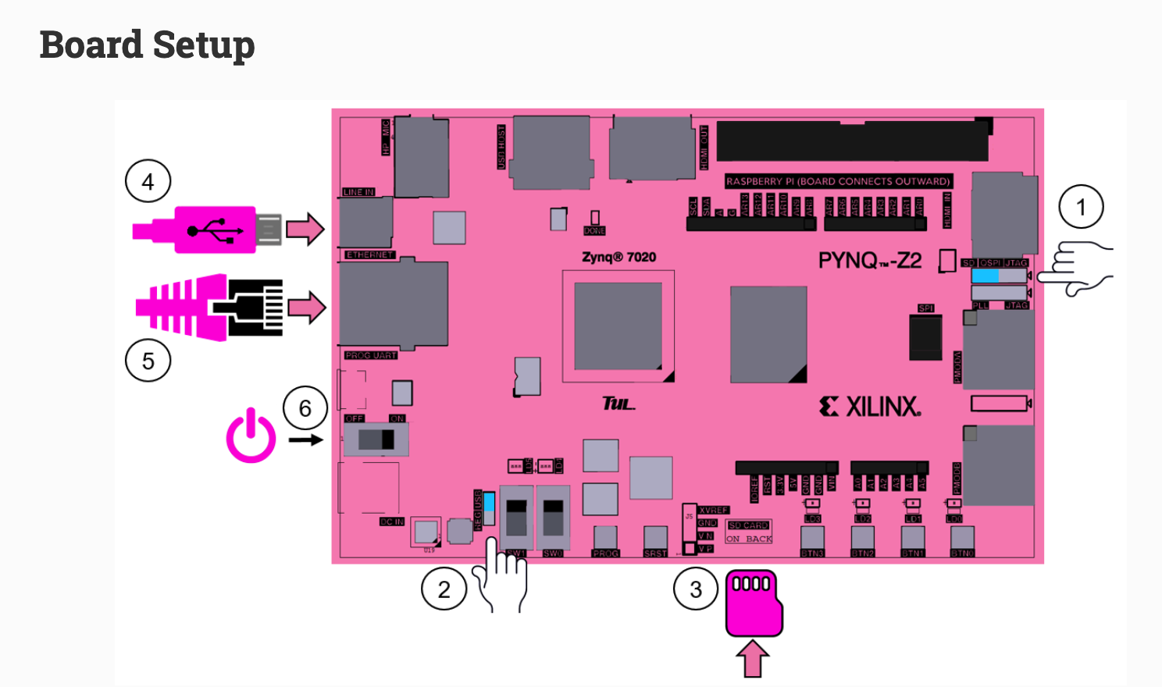

1. Set the ** Boot** jumper to the *SD* position. (This sets the board to boot from the Micro-SD card)
2. To power the board from the micro USB cable, set the **Power** jumper to the *USB* position. (You can also power the board from an external 12V power regulator by setting the jumper to *REG*.)
3. Insert the Micro SD card loaded with the PYNQ-Z2 image into the **Micro SD** card slot underneath the board
4. Connect the USB cable to your PC/Laptop, and to the **PROG - UART** MicroUSB port on the board
5. Connect the Ethernet port by following the instructions below
6. Turn on the PYNQ-Z2 and check the boot sequence by following the instructions below